Given a rows x cols matrix grid representing a field of cherries. Each cell in grid represents the number of cherries that you can collect.

You have two robots that can collect cherries for you, Robot #1 is located at the top-left corner (0,0) , and Robot #2 is located at the top-right corner (0, cols-1) of the grid.

Return the maximum number of cherries collection using both robots  by following the rules below:

* From a cell (i,j), robots can move to cell (i+1, j-1) , (i+1, j) or (i+1, j+1).
* When any robot is passing through a cell, It picks it up all cherries, and the cell becomes an empty cell (0).
* When both robots stay on the same cell, only one of them takes the cherries.
* Both robots cannot move outside of the grid at any moment.
* Both robots should reach the bottom row in the grid.

**Example 1:**

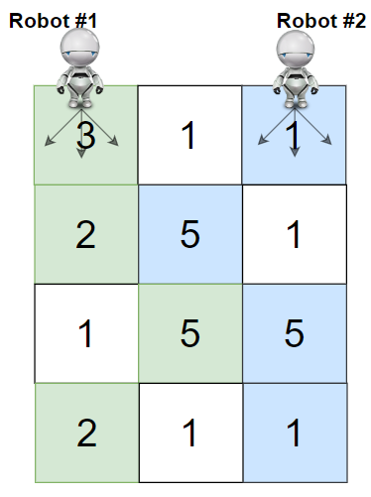

**Input:** grid = [[3,1,1],[2,5,1],[1,5,5],[2,1,1]]

**Output:** 24

**Explanation:** Path of robot #1 and #2 are described in color green and blue respectively.

Cherries taken by Robot #1, (3 + 2 + 5 + 2) = 12.

Cherries taken by Robot #2, (1 + 5 + 5 + 1) = 12.

Total of cherries: 12 + 12 = 24.

**Example 2:**

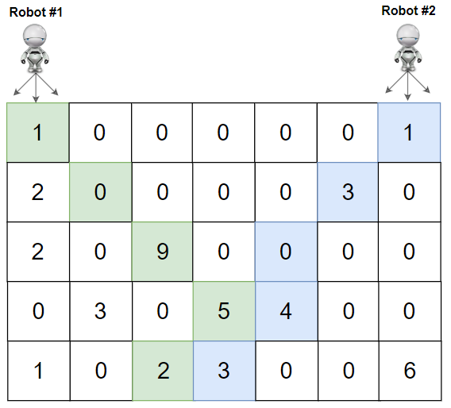

**Input:** grid = [[1,0,0,0,0,0,1],[2,0,0,0,0,3,0],[2,0,9,0,0,0,0],[0,3,0,5,4,0,0],[1,0,2,3,0,0,6]]

**Output:** 28

**Explanation:** Path of robot #1 and #2 are described in color green and blue respectively.

Cherries taken by Robot #1, (1 + 9 + 5 + 2) = 17.

Cherries taken by Robot #2, (1 + 3 + 4 + 3) = 11.

Total of cherries: 17 + 11 = 28.

**Example 3:**

**Input:** grid = [[1,0,0,3],[0,0,0,3],[0,0,3,3],[9,0,3,3]]

**Output:** 22

**Example 4:**

**Input:** grid = [[1,1],[1,1]]

**Output:** 4

**Constraints:**

* rows == grid.length
* cols == grid[i].length
* 2 <= rows, cols <= 70
* 0 <= grid[i][j] <= 100